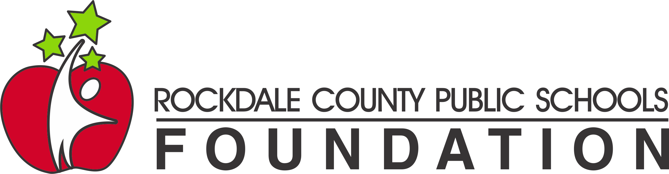

RCPS Foundation Scholarship Application 2024

The Rockdale County Public Schools Foundation (RCPS Foundation) will award a $1,000 scholarship to a qualifying senior at each of the following schools: Heritage High School, Rockdale County High School, Rockdale Magnet School, and Salem High School. Applicants must demonstrate their commitment to achievement and intend to continue their education at a college/university or technical school upon high school graduation. The RCPS Foundation will announce each school’s recipient at their respective Senior Awards program.

To apply, a student must:
- be on target to graduate in May 2024 from a Rockdale County school: Heritage High School, Rockdale County High School, Rockdale Magnet School for Science and Technology, or Salem High School
- have been admitted to a college or technical school for the 2024-2025 school year,
- have not received over $2500 in scholarships from other sources, and
- complete an application, including the video essay portion.

Video Essay: (2 minutes maximum)
Congratulations! You are graduating from a public school in Rockdale County! In a video of no more than 2 minutes, please articulate how your experiences in Rockdale County Public Schools have influenced your decision to pursue your goals of attending college or a technical school. Be sure to describe why education matters to you and your community and how you might support public education in the future. Include the name of the school you plan to attend, the major or area of study you plan to pursue, and your career goals.

Creativity and presentation skills will be considered by the judges.

Visit www.RCPSFoundation.com/Scholarship to complete the application and upload your video. Video formats accepted include the following extensions: mov, mp4, aiv, qt, mpeg, mpe

Submission Deadline: midnight on Wednesday, April 10, 2024
www.RCPSFoundation.com/Scholarship

Rockdale County Public Schools Video Release Form
By signing my name below, I give my permission for the video submitted by my child for the 2024 Rockdale County Public Schools Foundation (RCPS Foundation) Scholarship Program to be used by the RCPS Foundation for publicity purposes. This includes, but is not limited to, posting on the RCPS Foundation’s website and Facebook page, sharing via email distribution lists, and showing the video at the RCPS Foundation’s annual Gala event.

Student’s Name: ________________________________________________________________
Parent/Guardian’s Name: _________________________________________________________
Parent/Guardian’s Signature: ______________________________________________________
Date __________________________________________________________________________

